Use case
- Use case admin :
Generate puzzle
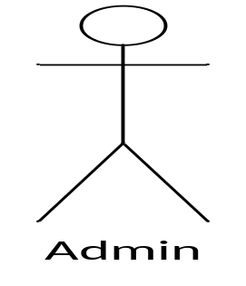
login
Delete puzzle
logout

- Use case player :
New game

Player name
High scores
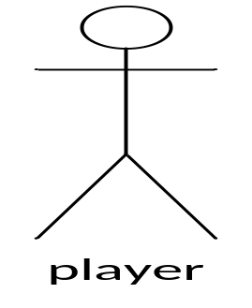
Select game
Login game
Play game
Submit puzzle
help
Exit game
View score and answers

